IdeaLoGee

Ayush Singhal (181500181)

Aditya Pratap Singh (181500045)

Yashvardhan (181500833)

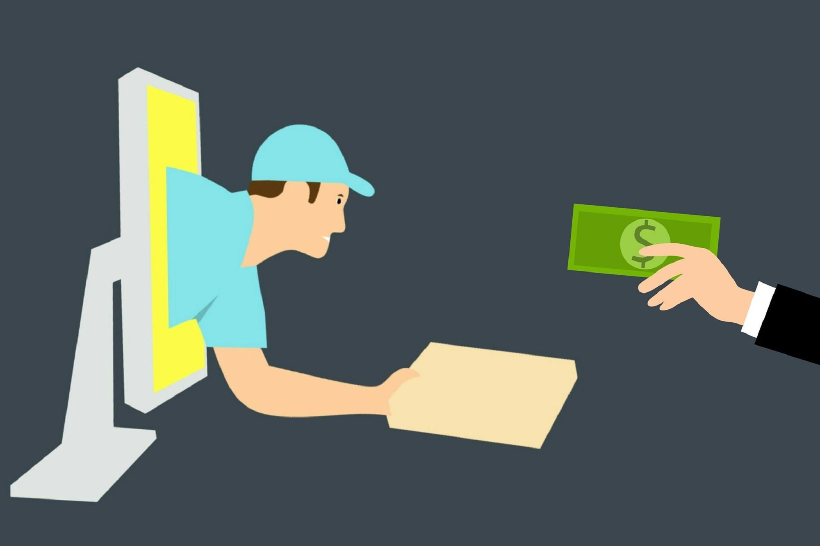

“An E-commerce website”

**Problem Statement**

As we all know the last year was tormenting for human generation and was a period of great depression in terms of both economy and development, as we all know the development of a country is measured by the extent of ideas and experiments that occur in a country but due to COVID-19 it became very difficult to share ideas, so a proper bridge is required between thinkers and doers. So, our idea is to bridge the gap between these two, that is those people who have some idea about the goods or product which can be useful for others, and those who are in need of the solution of the same problem.

**Reason for selecting the topic**

The reason for selecting this topic was to provide support to the people who have very interesting ideas in their mind but do not get a proper platform for showcasing their talent to the world. They can show, sell their idea to others using our site.

**Objective of the Project**

Through IdeaLoGee, we will provide an open platform for those people who have idea about anything whether it can be a product or any other real time problem and we will connect these problem solvers with those who are seeking the solution of the same problem. Our platform will be open for all. Anyone can come here, provide details about their idea and sell it from here or people who are interested in the ideas here can contact to the owner to know more about the idea.

**Contribution of the Project**

Our project will highly benefit for those who have their own idea about a product and needs a platform to showcase their product to the world so that people can take benefit from their ideas.

**Feasibility Study**

Talking about the feasibility of this project, in the current scenario, there are not many websites out there who provide such type of platform to sell ideas online for the people having various ideas.

Other supporting reason is the amount of people surfing internet every second for various reasons, they might get interested into the ideas if they will come to know about that.

The graph below shows that 67% people surfing the internet for searching about information during their leisure.

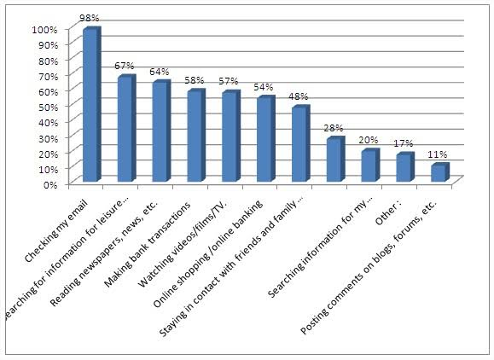

**Methodology**

In this project, we will use Front End Technologies like HTML, CSS, JavaScript (using React.js) to design our website. We will keep our website design responsive so that it will work smoothly on all gadgets. We will also use some creative software like Adobe Photoshop and Adobe Illustrator to design the logo and make images of items to be displayed clear.

For Back End technologies like Express.js and Node.js for communication with database and server and MongoDB for storing the data into the database will be used.

So, in short, we will use Full Stack for the development of our project.

**Scope for Extension into a Major Project**

**Our project has a great scope for extension into a major project. We will provide a chatting option where the owner of the idea and the other party who is interested in it can chat more about the idea. Also, we will create a mobile application for ease of both parties i.e., owner of idea and buyer, to browse and communicate as nowadays its all about mobile apps and applications for user ease.**

**Future Scope**

For the future, we intend to cover more and more people so that more number people get benefitted using our platform and also will update our website, platform and application according to future needs.

**Hardware and Software to be used**

**Hardware:**

1. Laptop or PC with the following configuration (minimum, for decent execution):
   * ***Processor***: Intel Core i3 6th Generation
   * ***Ram***: 4GB
   * ***OS***: Microsoft Windows 7 or above

**Software:**

1. ***GitHub***: For hosting the website (At the initial stage) and to store the website design and related stuff.
2. ***Front End Technologies:***
   1. HTML5
   2. CSS 3
   3. JavaScript using React.js
3. ***Back End Technologies:*** 
   1. MongoDB – document database
   2. Express.js – server-side web framework
   3. Node.js – premier JavaScript web server

**Testing Technologies to be used**

* **Hardware:**

1. Desktop
2. Laptop
3. Tablet
4. Cellphone

* **Software:**

1. ***Browsers (for compatibility check):***
   1. Google Chrome
   2. Mozilla Firefox
   3. Microsoft Internet Explorer
   4. Microsoft Edge
   5. Apple Safari
2. Search Engines

**Conclusion**

Overall, we can conclude that this project will be going to help a lot of people out there.

In future, we’ll cover more topics and fields and will try to make our website more user friendly and platform compatible on the basis of user feedbacks. Also, it’ll beneficial for us as it’ll give us exposure to working on the project and also for the those who have some world changing ideas but are unable to share them with those in need of the solution of the same.

This project will also boost the **Make in India** initiative as it will promote entrepreneurship in the country and will give a valuable contribution towards the development of the country.

**References / Bibliography**

1. Google
2. Wikipedia
3. Tutorial sites
4. Bing images